SC2107 Lab4 Assignment Sheet (to be submitted to NTULearn before next lab)

Name: Saravanakaleeswaran Arun Karthick Lab Group: SCEC Date: 16/10/2024

1. Section 6.1. What is the issue when an obstacle is placed too close to the IR sensor? What can you do to prevent such ambiguity?

* **Answer Q1 Section 6.1:** When the object is too close to the IR sensor, the sensor’s output can become ambiguous due to the non-monotonic behaviour in the voltage distance relationship. To avoid such ambiguous behaviour, we can ignore distances too close to the sensor by setting a minimum threshold (for e.g., In this lab, we can ignore the distance from 0 to 50 mm as stated in the lab manual).

1. Section 6.1. What is the purpose of the 10uF decoupling capacitor?  
   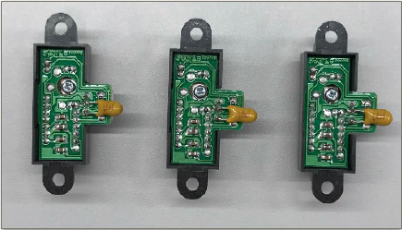

* **Answer Q2 Section 6.1:** The diagram below shows the connection between the IR sensors and the MSP432. The right, left and center sensors are connected to the pins 9.0, 9.1 and 4.1 respectively and from the MSP432 datasheets it corresponds to the ADC17, ADC16, ADC12 of the MSP432. The sensor is very noisy, thus the decoupling capacitor is required (in this case we us a 10uF capacitor).

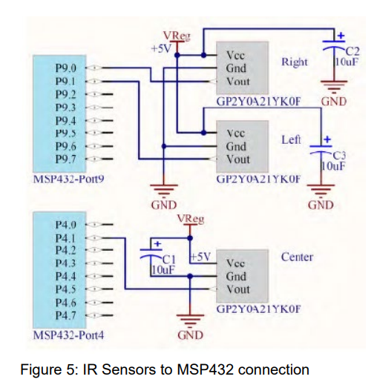

1. Section 6.2. Which port pins is ADC Ch12, 16 and 17 inputs mapped to? Which PxSELx and what settings are required to configure the pins to ADC function?

* **Answer Q3 Section 6.2:** ADC channel 17 is mapped to pin 9.0, ADC channel 16 is mapped to pin 9.1, ADC channel 12 is mapped to pin 4.1. The configurations are as follows:

P9.0 (ADC channel 17)**:** P9SEL0.bit0 = 1 and P9SEL1.bit0 = 1

P9.1 (ADC channel 16): P9SEL0.bit1 = 1 and P9SEL1.bit1 = 1.

P4.1 (ADC channel 12): P4SEL0.bit1 = 1 and P4SEL1.bit1 = 1.

1. Section 6.2. With respect to the ADC on MSP432, what are the two stages involved in every Analog to Digital Conversion of an Analog signal?

**Answer Q4 Section 6.2:** As shown in the figure below, the two stages involved in every Analog to Digital Conversion (ADC) of an analog signal are the sample and hold period (denoted in red) and the actual Successive Approximation Register (SAR) ADC conversion (denoted in blue).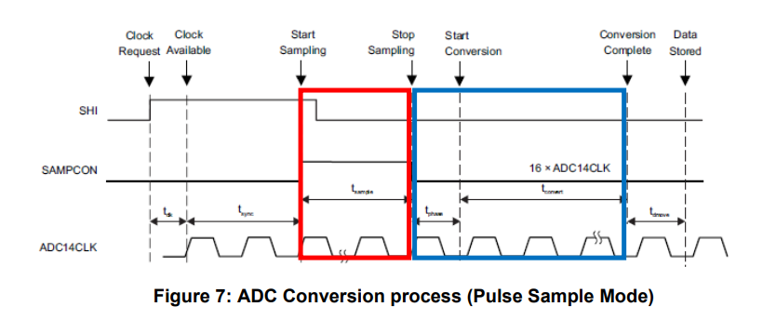

1. Section 6.3. What does the function LPF_Calc() does? What are the initial values of the buffer associated with LPF_Calc()? Why do we need this function?

* **Answer Q5 Section 6.3:** The function LPF_Calc() implements a low pass filter on the ADC output values, helping reduce noise and improving accuracy and stability. The initial values of the buffer can be the average of several initial ADC readings to establish a baseline or a constant initial ADC reading. This function is essential to reduce the impact on noise on sensor readings, giving us stable and accurate results.

1. Section 6.3. Describe the algorithm you used to estimate the actual distance based on the IR Sensor value.

* **Answer Q6 Section 6.3:** We first calibrate the IR sensor to calculate the actual distance from the IR sensor. We then store the results by measuring the output voltage of the IR sensors at known distances (we discard the distances up to 50m. The ADC will the convert these analog voltage values to discrete logic levels. The relationship between ADC and voltage is:

Voltage = (ADC Value / 2n−1)×Vref

After recording sufficient values, we can follow one of the two methods:

1. Making an exact curve fit using the hyperbolic equation X = A/(n + B) or use other polynomial or log functions for curve fitting.  
2. Doing a piecewise linear approximation, e.g. partition the curve into sectors of 100 mm and fit a straight line (y = mx + c) within this sector, repeat for other sectors.  
Once we have created the graph/mapping, we can use it to estimate the distance based on the IR sensor value (output voltage).

1. Section 7.2. Which timer capture input (Timer and Channel number) does P10.4 and P10.5 correspond to?

* **Answer Q7 Section 7.1:** P10.4 corresponds to Timer_A3, Channel 0 (TA3CCI0A).

P10.5 corresponds to Timer_A3, Channel 1 (TA3CCI1A)

1. Section 7.2. Which edge (falling, rising, both) is the timer input capture configured to trigger on? What happens when a capture event occurs?

* **Answer Q8 Section 7.2:** The timer input capture is configured to trigger on the rising edge of the signal input. When a rising edge is detected, the current timer count is latched into the capture register associated with that channel and an interrupt is generated for the respective channel, triggering an ISR for that. In the ISR, the difference between the current and previous timer values is calculated to get the period of the square wave pulse.

1. Section 7.2. Why is the calculated value of pulse duration, derived from the timer capture values, not a constant value but seemed to keep changing?

* **Answer Q9 Section 7.2:** The calculated value of pulse duration derived from the timer capture values tends to fluctuate. This could be due to noise, environmental issues and etc.